The Game of “Hyperspace Cheese Battle”
Hyperspace Cheese Battle is a game of intergalactic conflict and racing. And cheese. Between 2 and 4 players can play. Each player controls a rocket which they move through space. Moves are controlled by the use of a multi-faceted random value indicating system, otherwise known as a dice. Players roll the dice to move their rockets onto space quadrants, otherwise known as squares. Certain parts of space are infused with “Cheese Power” which can be used by the advanced technology in the ships to perform special actions.
Rocket Moves
Each player takes it in turn to throw one dice. They start off the board at the bottom left hand corner and move their rocket onto the board with their first throw of the dice. At each turn they must then move their rocket that number of squares over the board in the direction of the arrow on that square. If their throw would take them off the board their rocket is not moved.
If they land on a cheese square they can perform one of two actions:
- Absorb the cheese power from the square and use it to refuel their engines, allowing them to roll their dice again for an extra move.
- Absorb the “Cheese Power” from the square and create a “Cheese Death Ray” which they can fire at any another player. This causes the engines of that rocket to explode, sending it back to the bottom row of the board. The player being sent to the bottom can choose any unoccupied square on the bottom row.
Play continues until a player manages to travel to the square at the top right hand corner. The first player to do this is the winner of the game.
The laws of space and time do not allow a rocket to occupy the same hyperspace as another. If a move would cause a rocket to land on an occupied square the rocket is moved to the next free square in the direction of the arrow on the occupied square. If that square is also occupied the rocket is moved in the direction of the arrow of the next occupied square until an empty square is found.
Beginning the game
Enter the number of players playing and press enter. Note: the maximum players that can play is 4.
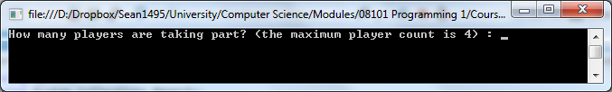
Each player must then enter their name and press enter as the game asks for them. Note: you cannot choose a name that has already been taken.
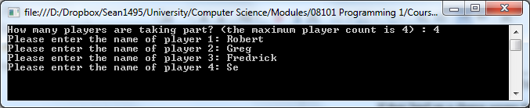

Player Turns
The game will automatically go through each player and throw the dice for them. The value the dice lands on and the player’s position will be printed and updated on the board. If the player lands on an occupied space then the dice will be rolled again – the dice will keep rolling as long there is occupied squares. Once all the player’s dice rolls are over a status report will be shown. This will show the number of player’s playing, their names and their current position.
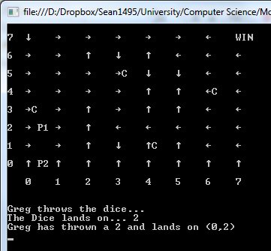
Cheese Power
Some of the squares are infused with cheese power. When the player lands on a cheese square the game will ask whether to use the cheese power to refuel their engines or use the cheese death ray.
- To use the cheese power as a cheese death ray type “D” and press enter.
- To use the cheese power to refuel the rocket engines type “R” and press enter
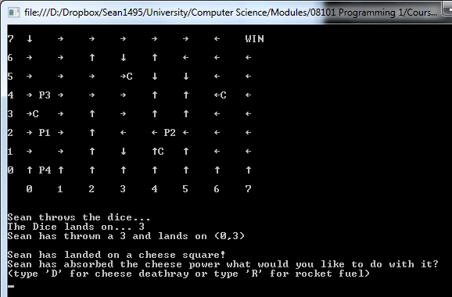

Cheese Power – refuel rocket engines
When the player chooses this option the game will automatically roll the dice again for the player that absorbed the cheese power.
Cheese Power – cheese death ray
When the player chooses this option the game will ask for the player to choose a target. The game will ask to type the player number and press enter to target that player. Note: the player which has absorbed the cheese power cannot target themselves.
Once the player has been targeted the cheese death ray will fire and explode the engines of the targeted player – sending them to the bottom of the board (the y coordinate will now equal 0). The targeted player now must choose what X coordinate to land on. Type a number between “0 – 7” and press enter.
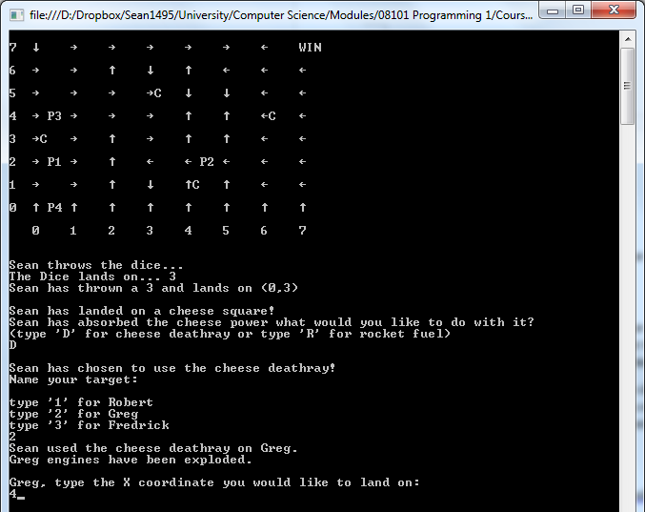
Winning and resetting the game
Once a player lands on the WIN square (coordinates: 7, 7) that player has won the game. The game will then end and ask to play again.
- If you do type “Y” and press enter
- If you don't type “N” and press enter
